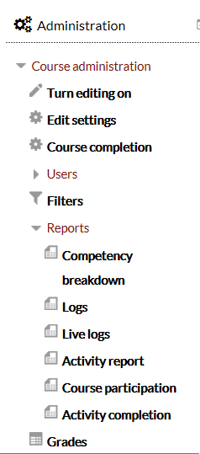
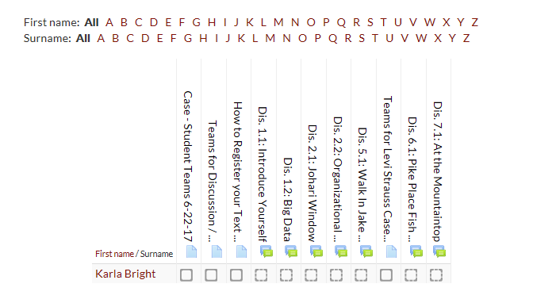
Viewing the Activity Report
Click on Reports in the Administration Panel and then click on Activity Completion

The report (shown below) will show the students that have met the condition set for the items in the report

