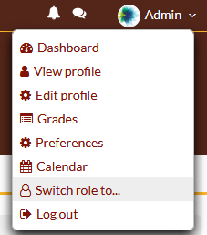
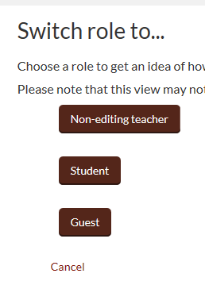
Hover over your name and the menu will pop out
Click on Switch role to
Click on a role

