Technology Services Helpdesk  Located on the first floor of the library next to the main computer lab.  Hours of operation:  Spring  M-F 8:00 am - 5:00 pm  Summer  M-F 8:00 am - 4:00 pm  Fall  M-F 8:00 am - 5:00 pm |  | 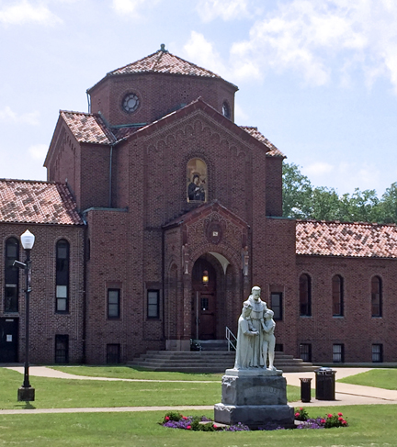
If you can’t find answers in the support sections below, feel free to call (716) 375-7600 or email questions to helpdesk@sbu.edu

If you are having technical issues and need assistance, please click on the Support ticket image to submit a support ticket.
General Resources & Information
SBU Student Account  - Your SBU username and password grant access to your email, My SBU, Moodle and other sites  - Learn more about your username and password and how to keep it safe  Bonaventure Email  - Your official email that will be used for contacting offices and faculty  - Office 365 Clutter Feature  Moodle  - Many SBU instructors utilize Moodle, our online instructional courseware program  - Check grades, upload assignments and perform other tasks |  | Frequently Asked Questions (FAQs)  - How can I set up my SBU email to my smartphone?  - Why won't my phone send emails?  - What services does the Helpdesk provide?  Student Printing  Students can now print from your own devices including your laptop, tablet or cell phone. There are over 20 printers around campus including the academic buildings, the library and several of the dorms. To learn more about printing click here.  SBU Policies  - SBU Printing Policy  - Computer Use Policy  - Online File Sharing
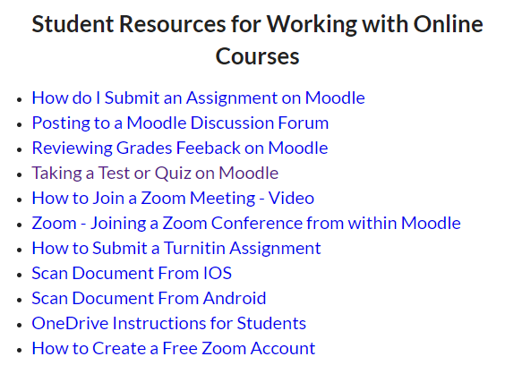 |  | Employee Resources  Links to online Office 365 Help Resources  Link to Online Teaching & Business  Resources page
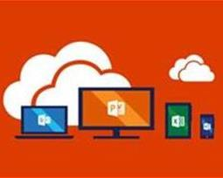  St. Bonaventure is giving you Microsoft Office for FREE | Download Office 365 on up to five devices!  Microsoft Applications Included: Word, Excel, PowerPoint, Outlook, Access, Publisher  Compatible with: Macs, PC, Android, iOS devices | Spectrum Cable TV  Students wanting cable TV in their room must contact Spectrum directly at either of the numbers provided below. They will provide you rates and channel lineup for their current packages. This is a direct contract between you and Spectrum.  877-636-3278  877-470-2023  Be sure to include your PO Box number in the service address.
Staff images | Staff images | Staff images

