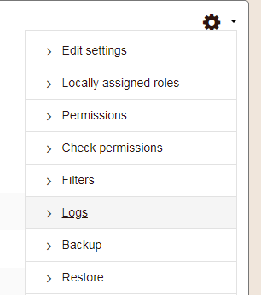
Click on the discussion board that you want to see the activity for

Under the Edit menu (Gear)
Click on logs
On the Logs page select the criteria – you can choose one student or all the participants.
Click get these logs.
You can download the results to excel and the bottom of the page.

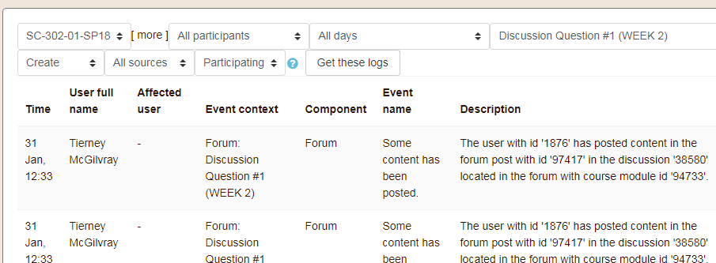
Second way to view logs
Click on the Edit Menu Gear
At the bottom of the list click on More
Scroll down to the Reports section
Click on Logs – there are various options here
The Course Participation – shows how much the student you choose has interacted with the activity you choose

