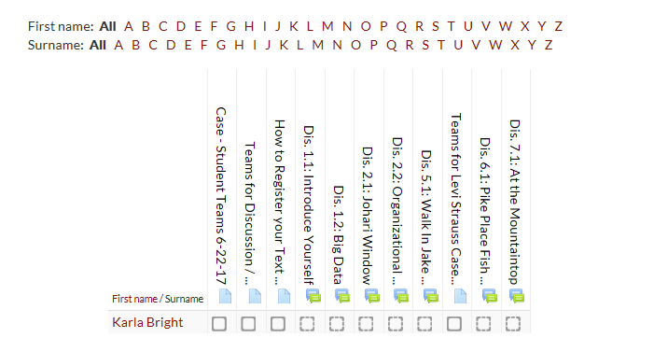Viewing the Activity Report

Click on **Reports** in the Administration Panel and then click on **Activity Completion**

The report (shown below) will show the students that have met the condition set for the items in the report

