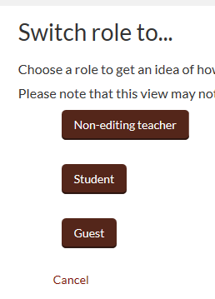

Hover over your name and the menu will pop out

Click on Switch role to

Click on a role

