VLOOKUP is the function to use when you need to find or compare information in a large set of data. The function looks at a value in one column and finds the corresponding value on the same row in another column.
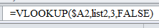
VLOOKUP Essentials
- Use VLOOKUP with lists or tables arranged in vertical columns.
- Your lookup_value MUST be in the first or leftmost column. It doesn’t matter physically where the first column starts: it could start in column A, or it could start in column K. Wherever it starts, the lookup_value argument must exist in the first column of the list or table. If your lookup table starts at column R and ends at column T, column R is considered the leftmost column.
- To find the column that contains the search result (the col_index_num argument), you literally count, starting from the left, or first column. For example, if your search result is in column C, the col_index_num argument would be number 3.
- If you leave the range_lookup argument off (which is either True or False), the formula defaults to True.
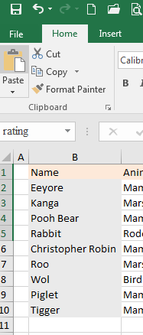
- Use absolute cell references, or a named range, if you copy the formula down a column.
Reference information: VLOOKUP: What it is, and when to use it
**Download and save on your computer the VLOOKUP Practice Workbook.
In VLOOKUP Practice Workbook we have the Name, Animal, Poohsticks Score, Rating and a “range” titled Rating Scale
It is important when using VLOOKUP to have a Unique Identifier for your data and in this case it is the Name field.
- Open the VLOOKUP Practice Workbook

- Notice we have 2 sets of information, our animal list and our rating scale
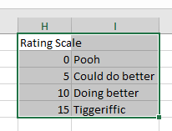
- Make sure that the look up range (rating scale) is sorted Smallest to Largest
- On the worksheet, highlight the Rating scale data range (H1 – I5)
- Click in the Name Box and name the range rating (no spaces)
press Enter on your keyboard
- Click on the Save Icon (ctrl + s)

- Click in cell D2 to make it the active cell
- Click on the Formulas Tab – click on Lookup and Reference – click on VLOOKUP
- In the Function Arguments dialog box (see image below), the Lookup_value is the cell reference that contains the Poohsticks Score type C2 in the Lookup_value text box or click on Cell C2

- The Table_array is set of data that we are looking in for the corresponding information
  - Click in the Table_array text box
  - Press the f3 key on your keyboard to bring up the Paste Names dialog box
  - Select the named range rating and click OK
  - You can also click on the collapse button and highlight your range of cells where you have the Rating Scale
- Col_index_num is the column number where the data I want added to the Rating column is located
  - Click into the Col_index_num and type 2
- Range_lookup is a logical value that specifies whether you want this function to find an exact match or an approximate match. If TRUE or omitted, an approximate match is returned. If FALSE, this function will find an exact match. If a match is not found, the error value #N/A is returned.
  - Leave this blank – since we are using a range to numbers (0 to 4), (5 to 9), etc…
  - Click OK
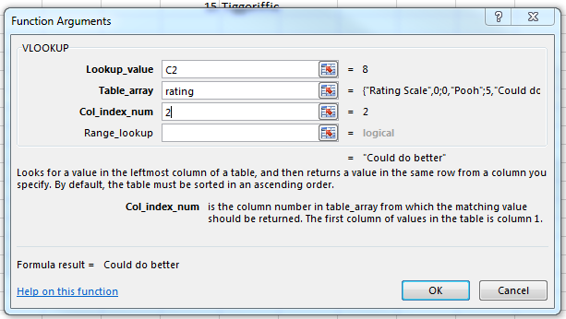
The image below shows the dialog box and the values you should in each Function Argument

References and Resources

Quick Reference Card
http://officeimg.vo.msecnd.net/en-us/files/818/530/AF101984660.pdf
Microsoft Office Training Course
http://office.microsoft.com/en-us/excel-help/vlookup-what-it-is-and-when-to-use-it-RZ101862716.aspx?CTT=1
Microsoft Office Blogs
http://blogs.office.com/
Compare Values in different Excel Worksheets
http://www.youtube.com/watch?v=HSIX7Hg3bxQ
How to Combine 2 Excel Workbooks Using VLOOKUP
http://www.youtube.com/watch?v=809m6kLTfgI

